Trinity Western University
Math 101 Survey Exam

Name: _________________________

Student ID No. ___________________

Time: 60 minutes

All TWU students enrolling in Ma101 at TWU are required to write this exam. The purpose of this survey exam of high school mathematics is to provide an indication of the overall level of Math skills for incoming students. This examination does not carry degree credit nor does it become part of a permanent student record.

A scientific calculator is allowed, but not required.
Note: Questions 26-30 optional – Math 12 content

Questions:

- Last High School Math course completed.
  - Math 12 _____________.
  - Math 11 _____________.
  - Other (specify) __________________.
- When was your last High School Math course completed?
  - Less than 6 months ago ____________.
  - 7 to 12 months ago _______________.
  - More than one year ago ___________.
- Letter grade achieved on your last High School Math course.
  - A or 80% plus ___________.
  - B or 70-79% ____________.
  - C or 60-69% ____________.
  - Pass 50 to 59% __________.
  - Fail below 50% __________.
- What Major are you pursuing?
  - Business or Finance _______________________.
  - Biology _________________________.
  - Teaching _____________________.
  - Psychology ______________.
  - Religion _______________________.
  - Other (Specify) _________________.
- Do you plan to attend the Tutorial Sessions?
  - Always ___________
  - As needed ________
  - Never ___________
  - Comments
____________________________________________________________________________________
____________________________________________________________________________________
Instructions: 1) Circle the best answer and transfer to Scantron.
2) Do Not Guess. Omit any questions you do not understand

Part A: General Knowledge (2 marks each)

- (-1)⁹⁶(-2)⁵ equals
- -32 | - 32 | - 10 | - -10 | - 2¹⁰¹

- If 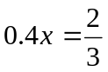, then x equals
- 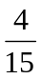 | - 0.6 | - 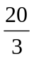 | - 

- If x, y, and z are positive numbers and 3x = 5y = 2z, then
- x < y < z | - y < x < z | - y < z < x | - z < y < x | - x < z < y

- If the length of a diagonal of a square is d, the area of the square is
- 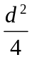 | - 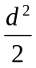 | - d² | - 2d² | - 4d²

- If a = -2 and b = -5, then (b - a)² is
- 49 | - 29 | - 21 | - -9 | - none of these

- The average (mean) of 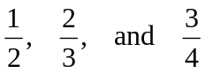 is
-  | - 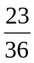 | - 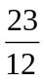 | - 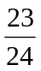 | - none of these

- The number 28 can be expressed as the sum of two prime numbers in two different ways. The sum of the smallest two of these four primes is
- 3 | - 5 | - 12 | - 16 | - none of these

- 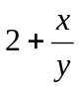 equals
- 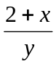 | - 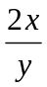 | - 2y + x | - 2x + y | - 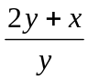
- In each of three successive years, the cost of living increases by 10%. The percentage increase over the three years is
- 30 | - 130 | - 33.1 | - 33 | - 133.1

- Tom and Dick shared all the marbles in a bag in the ratio of 5 to 3. Tom received 10 marbles more than Dick. The number of marbles in the bag originally was
- 40 | - 48 | - 80 | - 120 | - none of these

- The area of pentagon ABCDE is
A
E
16
3
- 48 | - 72 | - 96  12  C  12
- 108 | - 120
B
D

- If the circumference of a circle is π, then the area of the circle is
- 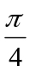 | - 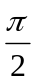 | - π | - 2π | - 4π

- (0.00000032) ÷ (1.6 x 10⁻³) is equal to
- 2 x 10⁵ | - 2 x 10⁴ | - 2 x 10⁻³ | - 2 x 10⁻⁴ | - 2 x 10⁻⁵

- 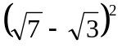 is equal to
- 4 | - 10 | - 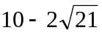 | - 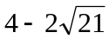 | - 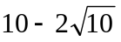

- A photograph measuring 8 cm by 10 cm has its length and width each tripled. The area of the enlarged photograph is now k times the area of the original photograph where k equals
 |  | - 3 | - 8 | - 9
Part B (3 marks each)

- If A(5, 9), B(2, 7), C(2, 1) are vertices of a triangle, the area of triangle ABC is
(5, 9)
- 5 | - 8 | - 9
- 11 | - none of these

(2, 1)
(2, 7)

x
y

- If the area of the shaded region is 19, then the area of square PQRS is
n + 2
S
P
Q
R
n + 2
- 5  n + 1 | - 7 | - 25
- 49  n | - none of these

- If 3 is a root of the quadratic equation 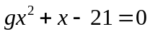, then the other root is
- 2 | - -3 | - 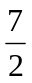 | - 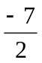 | - none of these

- An equation of a line having a slope of 2 and passing through (1, 3) is
- y = 2x + 2 | - y = -2x + 1 | - y = 2x + 5 | - y = 2x - 2 | - y = 2x + 1

- Solve the system of simultaneous equations
3x - y = 8
2x - y = 7
- (4, 4) | - (3, 1) | - (1, -5) | - (3, 2) | - none of these

- Solve x² - 4x - 3 = 0 and simplify. (Hint: use the Quadratic Formula, 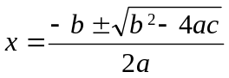)
- 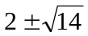 | - 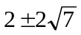 | - 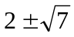 | - 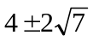 | - none of these

- Which of the following could be the equation of the function whose graph is shown
y
- x + y = 6  (2,4) | - y = x² | - y² = x
- xy = 8  x | - none of these

- For the function 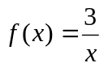, find 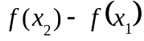 if 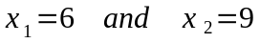
- 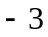 | - 3 |  | - 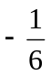 | - none of these

- If you toss a coin twice, what is the probability of getting two heads in a row?
-  |  | -  |  | - none of these

- If 10% of a doctor's patients need a hearing aid and 30% need glasses, and 5% need both, how many of the patients need neither a hearing aid, or glasses?
- 65% | - 60% | - 55% | - 45% | - 40%
Part C (4 marks each). For students who have completed Math 12.

- If 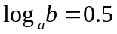, evaluate 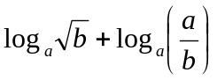
- 0.50 | - 0.75 | - 1.0 | - 1.5 | - none of these

- For the polynomial function 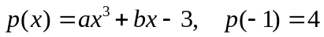. Determine the value of p(1).
- -10 | - -4 | - 4 | - 10 | - none of these

- 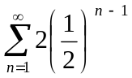 equals
- 1 | - 2 | - 3 | - 4 | - none of these

- Simplify 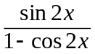
- cot x | - tan x | - 2 cot x | - 2 tan x | - none of these

- Which of the following functions describes the graph shown.
- y = sin x  2 | - y = sin (-x)
- y = sec x  1 | - y = -cos x
  - y = cos x
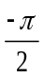
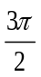
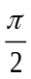
-2
-1
y
x

